Part – 1

docker pull infracloudio/csvserver:latest

docker run -itd --name csvserver_container infracloudio/csvserver:latest /bin/bash

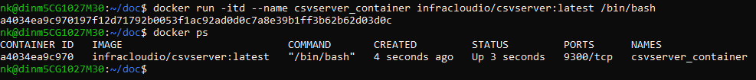  
  
touch gencsv.sh

#!/bin/bash

start=$1

end=$2

for ((i=start; i<end; i++))

do

echo "$i, $RANDOM" >> inputFile

done

chmod +x gencsv.sh

./gencsv.sh 2 9

docker stop csvserver_container

docker rm csvserver_container  
  
docker run -itd --name csvserver -v $(pwd)/inputFile:/csvserver/inputdata infracloudio/csvserver:latest



docker exec -it csvserver /bin/bash

netstat -tuln or ss -tuln

exit

docker stop csvserver

docker rm csvserver

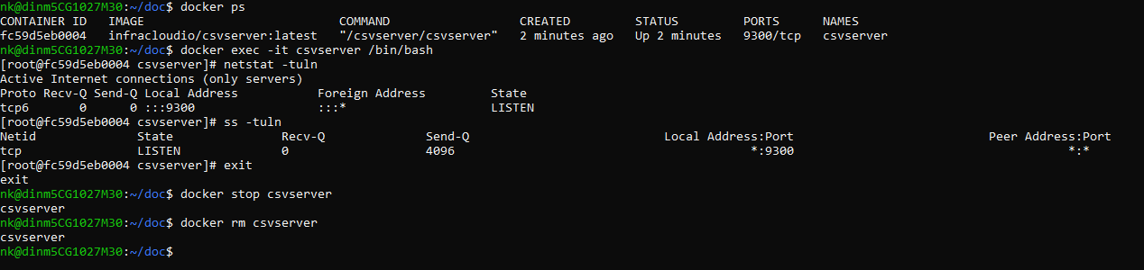

docker run -itd --name csvserver -e CSVSERVER_BORDER=Orange -v $(pwd)/inputFile:/csvserver/inputdata -p 9393:9300 infracloudio/csvserver:latest  
  


curl -o ./part-1-output <http://localhost:9393/raw> ( to generate part-1-output)

docker logs 3074584a02c2 >& part-1-logs ( to generate part-1-logs)

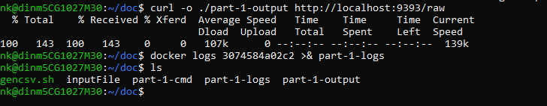

Part – 2

docker stop csvserver

docker rm csvserver

docker-compose.yaml file:  
  
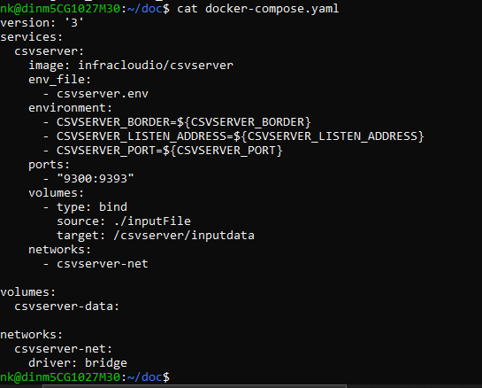

csvserver.env file:  
  
command: docker-compose up -d  
  
  
Part -3

docker-compose down

